## **INFM600-Rubric-PBJDocumentation**

The peanut butter and jelly sandwich is a tasty American staple. Follow the instructions below to make your delicious sandwiches!

**Materials**

* two slices bread per sandwich
* Peanut butter
* Jelly or jam
* A knife

**Step 1 Decide your materials’ type**

* **Recommended bread: Soft whole wheat or white bread.**

Generally, people do not want something that overwhelm their other flavors, so wheat or white bread is an ideal one. Otherwise, you can choose something you like.

* **Recommended peanut butter: organic peanut butter**

If you're looking for a healthier option, try an organic peanut butter, because **l**ots of types of peanut butter come with lots of added sugar and partially hydrogenated oils that are bad for your health.

**Pay attention:** Natural peanut butter may have a layer of oil on top, but if you carefully stir it in when you open in the jar and then keep the jar of peanut butter in the refrigerator, the oil will not separate out again.

* **Recommended jellies and jams: grape and strawberry**

The two most commonly used are grape and strawberry. However, you could branch out to a sharper taste like raspberry, or a mixture of several different kinds.

**Step 2 Spread peanut butter evenly onto one slice of bread using a knife.**

* **Decide how much peanut butter you want**

If you're going to taking a sandwich somewhere, you'll probably want to do a little light on the peanut butter, otherwise it will get everywhere before you get to eat it. For standard white bread, about 1 1/2 tablespoons of each will suffice.

* **Stir your peanut butter beforehand to soften it and make it easier to spread on the bread slice.**

**Tips:** If you have a bowl and a microwave, you can microwave it on high for about 20 seconds.

* Spread peanut butter evenly onto one slice of bread using a knife. You can use a spoon instead.

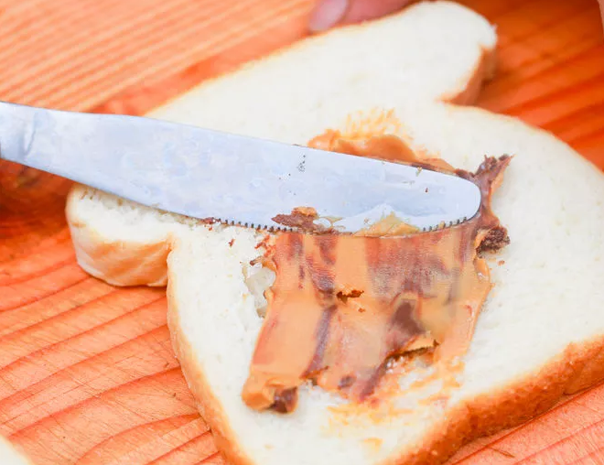

**Step 3 Spread jelly or jam evenly onto the other slice of bread with knife.**

Again, unless you're going to be eating it right there, try to avoid overwhelming your sandwich with jam.

**Step 4 Press two slices of bread together.**

To avoid having the peanut butter and jam run everywhere, do this quickly. A good way is to take both slices at the same time and quickly press them together.

**Step 5 Cut the sandwich.**

The best way to cut the sandwich is diagonal, from one corner to another, giving you two triangle shaped pieces.

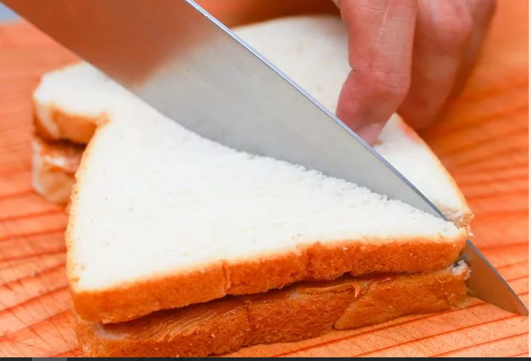

Otherwise, you can cut directly across the sandwich, leaving you with two rectangular shaped pieces.

**Step 6 Enjoy your easy and yummy looking sandwich!**

Just make sure that you wash your hands afterwards, because you'll be certain to get the gooey mixture of peanut butter and jelly on them.

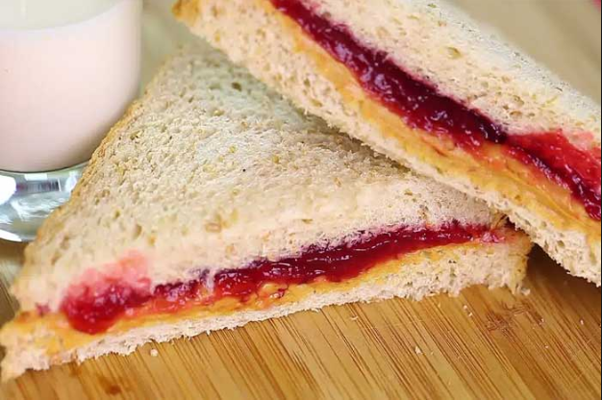

**FAQs:**

**Q:** Can I spread peanut butter and jelly onto both slices?

**A:** Of course, you can!

**Q:** Can I add other things?

**A:** Yes! You can get creative! Add some crunch like granola, pretzels, etc.

**Reference**

How to Make a Peanut Butter and Jelly Sandwich: 11 Steps. (n.d.). Retrieved October 22, 2016, from http://www.wikihow.com/Make-a-Peanut-Butter-and-Jelly-Sandwich

Total words: 517